**STANDARD OPERATING PROCEDURE**

**FOR**

**ACCOUNTS & FINANCE**

2017-18



For private circulation only

To be circulated strictly with the permission of Management committee

## OBJECTIVE

The aim of this SOP is to lay down necessary directives for the smooth and efficient administrative functioning of F&A Department and to ensure that Statutory compliances are made.

## 

## DELEGATION OF AUTHORITIES AND ACCOUNTS MANAGER

## With a view to improve the overall efficiency of funds management and to avoid delays in according sanctions for expenditure, the procedure has been outlined below.

The structure of F&A Department would be as follows:

## FINANCE & ACCOUNTS DEPARTMENT

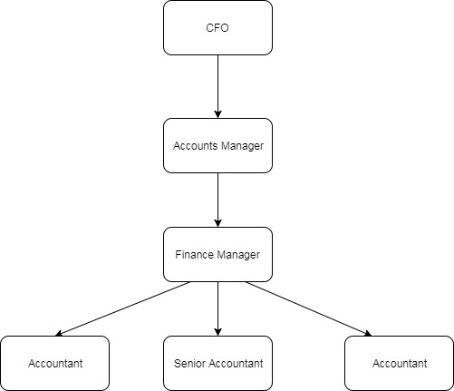

## KEY CONTROLS WITHIN F&A DEPARTMENT

## Income generation

## Student Application money is received through business development department

## Initial deposit needs to be paid by student in advance so that he/she will be listed in the book of accounts.

## Security deposit including 50% of fee has to be paid by the candidate for the allotment in particular hostel

## Payment of fees is done through NEFT transfer / online transfer and through checks. After the payment receipt is generated in accounts department and sent to business development department.

## So these records of fees payments are stored in book of accounts according to hostel wise and the year of admission

## For some universities, the accounts department of CSCPL would raise an invoice for student wise payment.

**Purchase Order**

* Purchase orders would be issued and signed by the relevant authoritative personnel. A copy of the signed PO should be provided to Finance & Accounts.

• Purchase orders will be received from the O&M and F&B department as per terms and conditions i.e. within 30/45 days.

• On receipt, these will be checked for the number of financial concurrence record there on and then entered in the register of purchase orders.

• Purchase orders and their amendments will be filled vendor wise.

* The PO would be consulted with Finance Manager before signing to review the statutory compliances, legal terms and conditions etc.

**Statutory payments**

* Statutory payments like PF,ESI are done on time to avoid the penalties.
* The statutory payments and their due dates are as follows:

**Statutory payments** **due date**

1. Provident Fund 15th of every month
2. TDS 7TH of every month
3. Service tax 5th of every month
4. GST 20th of every month
5. Professional tax 20th of every month

* 1. **Receipt of Bills**

The following procedures shall be followed at the time of receipt of bills.

* + 1. Entry shall be made giving details of the bills received such as date of receipt of invoice, name of vendor, date of invoice, description in the invoice, amount etc in the Manual Register maintained by Accounts officer.
    2. A unique serial number code on the top of the bill would be mentioned which would be same as the serial number on which the bill was entered in the manual register.
    3. The bill would then be approved by the COO/CEO for further processing.
    4. It should be ensured that the entry of the bills in the register will be made on the same day of receipt of bills from vendor and hand over the details to the senior accounts officer.

## Entry of Bill in the Books of Accounts

* + 1. After review of bill by the COO, the bill would be checked by Finance Manager with the Purchase Order/Agreement/Approval of the bill. He would ensure that necessary supporting documents are attached with the bill.
    2. The Finance Manager would check the TDS implication and Service Tax implications on the bill and provide for the same in the books of accounts accordingly.
    3. In case of purchase of any material or sports goods, relevant entry would be made in the stock register for the quantity and value and serial number given in the stock register would be mentioned in the Purchase Invoice before the purchase bill is is entered in the books of accounts.
    4. After the purchase bill is approved by the Finance manager, entry would be made in the books of accounts.
    5. It would be ensured that the entry of the bills will be made within 24 hours of receipt of bills from the accounts officer.
    6. Also it would be ensured that the Serial numbers are correct for posting the entry in books of accounts.

## Preparation of Approval note for payment

1. After the above steps, approval note for release of payment of the bill shall be prepared by the Accounts Officer along with the relevant supporting documents such as Original Invoice, Journal Voucher passed by the Sr. Accounts officer, agreement (wherever applicable).
2. After preparing the approval note, Accounts officer would ensure that the approval note is signed by the relevant authorities. Once this is signed by relevant signatories, the payment note would be approved by Finance Manager.
3. On approval of payment note by Finance Manager, the note along with supporting document should be sent to CEO for approval along with all the supporting documentation.

## Issue of Cheques

1. On receipt of approval of CEO, the Finance Manager would prepare the cheque on the basis of approval note signed by the relevant authorities.
2. After the cheque is prepared, the cheques should will be processed on the following dates :

For regular Payment On or before 10th of every month

For Salary and TDS 5th of the next month

For Service Tax 5th of every month month.

1. Once the cheques are signed, payment entry would be made in the books of accounts by Accounts Officer on the same day.

## Dispatch of Cheques

1. The cheques should be dispatched on the same day through courier unless they are hand delivered.
2. A control register would be maintained by Accountant for all the courier sent giving details of courier number, cheque no, name of party, amount and follow up should be done by Accounts Officer twice a week with the courier company on the delivery of the cheque so that the control register can be updated accordingly.

## Fixed Asset Register

Fixed asset register (FAR) will be maintained in the system. The FAR will contain the following details:

* Class and description of asset
  + Make/Manufacturer
  + Supplier and Model number
  + Date of purchase
* Quantity
* Location and Department using the asset
* Value of asset (gross block, net block)
* Useful life of Asset and depreciation rate
* Unit of Measurement
* Depreciation (accumulated depreciation and depreciation for the year)
* Details of transfer and disposal
* WDV of assets